Contents

[Keyboard 3](#_Toc182250433)

[External Overview of a Keyboard 3](#_Toc182250434)

[Overview of each section of the keyboard: 4](#_Toc182250435)

[InternalOverview of a Keyboard 5](#_Toc182250436)

[Mechanical switch keyboard 6](#_Toc182250437)

[Component of mechanical keyboard 6](#_Toc182250438)

[CRT Color Monitor 6](#_Toc182250439)

[Overview 6](#_Toc182250440)

[Internal Structure of CRT Monitor 7](#_Toc182250441)

[Color CRT Monitors 9](#_Toc182250442)

[Major Parts and Components of a Color Monitor 11](#_Toc182250443)

[Working Mechanism 12](#_Toc182250444)

[Dot-Matrix Printer 15](#_Toc182250445)

[Overview 15](#_Toc182250446)

[Mechanical and electronic parts of a Dot-Matrix Printer 16](#_Toc182250447)

[Inkjet Printers 19](#_Toc182250448)

[The primary components of an inkjet printer include: 20](#_Toc182250449)

[How Inkjet Printers Work? 20](#_Toc182250450)

[Maintenance And Troubleshooting Tips OF An Inject Printer 21](#_Toc182250451)

[Laser Printers 21](#_Toc182250452)

[The basic components of a laser printer include: 22](#_Toc182250453)

[How do laser printers work? 23](#_Toc182250454)

[Factors Affecting Print Quality and Speed 23](#_Toc182250455)

[Mouse 25](#_Toc182250456)

[External Parts of a mouse 25](#_Toc182250457)

[Internal Parts Observation 26](#_Toc182250458)

[Scanner 27](#_Toc182250459)

[Drum Scanner 28](#_Toc182250460)

[Flatbed Scanner 29](#_Toc182250461)

[Sheetfed Scanner 29](#_Toc182250462)

[Handheld Scanner 29](#_Toc182250463)

[HDD 30](#_Toc182250464)

[CD drive 32](#_Toc182250465)

[Figure 1. A mechanical keyboard 3](#_Toc182250494)

[Figure 2. This picture shows the way keys are laid out on a keyboard in general. 4](#_Toc182250495)

[Figure 3. Overview of keyboard 4](#_Toc182250496)

[Figure 4. Keyboard Keycaps 5](#_Toc182250497)

[Figure 5. The Design of Typical CRT Color Monitor 7](#_Toc182250498)

[Figure 6. Internal Structure Mechanism of CRT Monitor 8](#_Toc182250499)

[Figure 7. Beam Penetration Mechanism 9](#_Toc182250500)

[Figure 8. Shows the delta-delta shadow mask method commonly used in color CRT system. 10](#_Toc182250501)

[Figure 9. The shadow mask of CRT 10](#_Toc182250502)

[Figure 10. Triad and In-Line arrangement of red green and blue electron guns of CRT for Color Monitor 11](#_Toc182250503)

[Figure 11. Components of CRT monitor 12](#_Toc182250504)

[Figure 12. RGB Color Monitor and Composite Monochrome Color Monitor 12](#_Toc182250505)

[Figure 13. A Dot-Matrix Printer 15](#_Toc182250506)

[Figure 14. Disassembly parts of a Dot-Matrix printer 15](#_Toc182250507)

[Figure 15. Parts in a dot-matrix printer 16](#_Toc182250508)

[Figure 16. Printer Body 16](#_Toc182250509)

[Figure 17. Printer Cartridge 17](#_Toc182250510)

[Figure 18. Power Supply Unit of a Dot-Matrix printer 17](#_Toc182250511)

[Figure 19. Power Transformer of a Dot-Matrix printer 17](#_Toc182250512)

[Figure 20. Motherboard of a dot-matrix printer 18](#_Toc182250513)

[Figure 21. Stepper Motor of a dot matrix printer 18](#_Toc182250514)

[Figure 22. Print Head of a dot-matrix printer 18](#_Toc182250515)

[Figure 23: Inject Printer 19](#_Toc182250516)

[Figure 24: Inject Printer workflow 21](#_Toc182250517)

[Figure 25: Laser Printer 22](#_Toc182250518)

[Figure 26: Laser Printer workflow 23](#_Toc182250519)

[Figure 27. A Typical wired (left side) and wireless (right side) computer mouse 25](#_Toc182250520)

[Figure 28. External Parts of a Computer Mouse 25](#_Toc182250521)

[Figure 29. Internal Parts Observation of a mouse 26](#_Toc182250522)

[Figure 30. Microcontroller of a mouse Figure 31. Circuit board of a mouse 27](#_Toc182250523)

[Figure 33. Scanning method 28](#_Toc182250524)

[Figure 34.drum scanner 28](#_Toc182250525)

[Figure 35. Flatbed Scanner 29](#_Toc182250526)

[Figure 36. Sheetfed Scanner 29](#_Toc182250527)

[Figure 37. Handheld scanner 30](#_Toc182250528)

[Figure 38. HDD platter 30](#_Toc182250529)

[Figure 39.HDD spindle 31](#_Toc182250530)

[Figure 40. HDD Read/Write Heads 31](#_Toc182250531)

[Figure 41. HDD Actuator Arm (or Actuator) 31](#_Toc182250532)

[Figure 42. CD drive 32](#_Toc182250533)

# Keyboard

A **keyboard** is one of the primary input devices that allows users to input text into a computer or any other electronic machinery. It is a peripheral device that is the most basic way for the user to communicate with a computer. Using a keyboard is often called typing. It consists of multiple buttons, which create numbers, symbols, and letters, and special keys like the Windows and Alt key, including performing other functions.

The design of the keyboard comes from the typewriter keyboards, and numbers and letters are arranged on the keyboard in that way, which helps to type quickly. It contains many mechanical switches or push-buttons called "keys." When one of these is pushed, an electrical circuit is closed, and the keyboard sends a signal to the computer that tells it what letter, number, or symbol it would like to be shown on the screen. The computer then shows the character on the screen, usually at the place where the flashing text cursor is.

Besides entering characters, computer keyboards also have special keys that change the symbol (such as shift or caps lock) or give the computer special commands (such as the arrow keys, CTRL, and ALT). Different computer operating systems use different special keys or use them differently. Special commands can also be activated through combinations of keys, called keyboard shortcuts. Some of the most common shortcuts on Windows programs are: Ctrl + C, to copy some text or a picture; Ctrl + V, to paste what was copied; and Ctrl + F, to find a certain word on a document or web page.

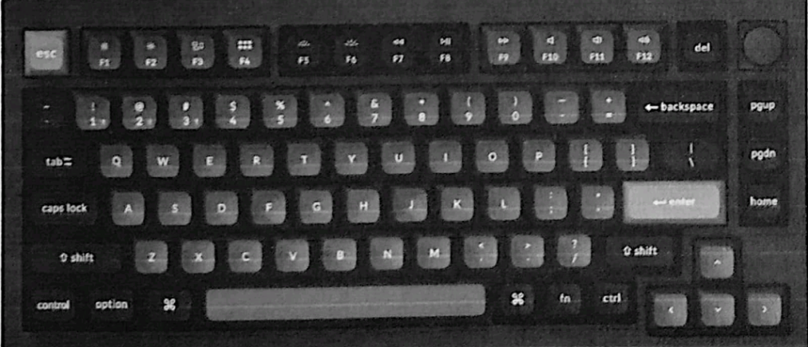

Figure 1. A mechanical keyboard

The above keyboard design is called **QWERTY** design because of its first six letters across in the upper-left-hand corner of the keyboard

## External Overview of a Keyboard

There are different types of keyboards. They can be based on the way the keys work. Most computer keyboards have the keys in six rows, but some laptops use only five or even four rows to save space. The most popular layout is called **QWERTY**, which is based on the first six letters on them. The QWERTY design was made so that the most common letters would not make the moving parts of a mechanical typewriter "jam," or stop working. Now, even though most people do not use typewriters anymore, the design stayed because people were used to it. Other layouts have been developed, for example, the **Dvorak** keyboard, which puts the most common letters in the places that are easiest to reach.

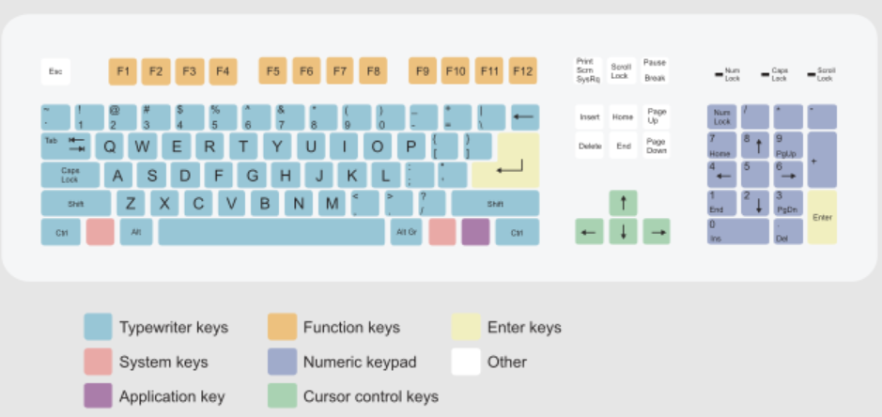

Figure 2. This picture shows the way keys are laid out on a keyboard in general.

## **Overview of each section of the keyboard:**

**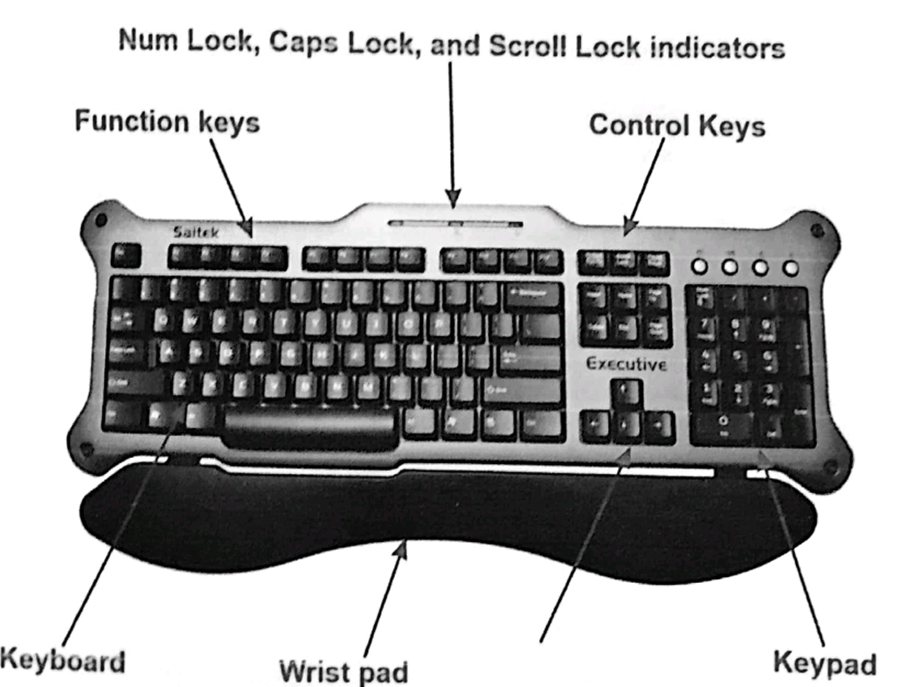**

Figure 3. Overview of keyboard

**1. Alphanumeric keys**: Most of the keyboard, which includes letters, numbers, punctuation, and certain symbol keys, is alphanumeric. There are rows of keys for each group of alphanumeric keys. These layouts are usually named after the first six letters on the first row. AZERTY, QWERTY, QWERTZ, QZERTY and national variants thereof

**2. Function keys**: Programs employ the function keys, sometimes known as the F1 through F12 or F19 keys, as shortcuts for frequently used actions. By using the F1 key, you may access online assistance for most programs. The function keys on some keyboards can be used to launch extra computer features

**3. Control and toggle keys**: The user has more cursor and text manipulation control thanks to the control and toggles keys. In many programs, they can also be used as shortcut keys. Cut keys are distinct from control keys.

**4. Keypad**: The keypad allows the user easy access to numbers and mathematical operations like plus, divide, times, and subtract, despite not being included on all computer keyboards, particularly laptops.

**5. Wrist pad**: The Saitek keyboard contains a wrist pad to assist the user's wrists. Hundreds of different wrist pads are available at a computer store or online, even though many keyboards do not come with one.

**6. Arrow keys**: The cursor can be moved, or a highlighted selection can be changed using the four arrow keys. Visit our arrow keys page for further details.

**7. Special keys or media keys on a multimedia keyboard**: Additional buttons on multimedia keyboards are absent from standard keyboards. Information on our special keys can be found there

## InternalOverview of a Keyboard

The internal structure of a keyboard is a complex system of components that work together to convert keystrokes into electrical signals that can be interpreted by a computer. Here's a breakdown of the key components:

**Keycaps:** These are the plastic or metal covers that you press on top of the switches. They come in various shapes, sizes, and materials, and can be customized to suit individual preferences.

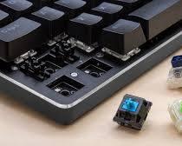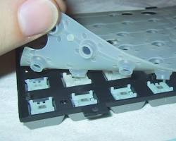[](https://www.amazon.com/XVX-Profile-Keycaps-Keyboard-Mechanical/dp/B0C1B6STX4" \t "_blank)

[Figure . Keyboard Keycaps](https://www.amazon.com/XVX-Profile-Keycaps-Keyboard-Mechanical/dp/B0C1B6STX4" \t "_blank)

**Switches:** Switches are the heart of a keyboard, responsible for detecting keypresses and sending signals to the controller. There are several types of switches, each with its own feel and sound:

**Membrane switches:** These are the most common type of switch in budget keyboards. They consist of a flexible membrane with conductive traces that complete a circuit when pressed.

**Rubber dome switches:** Similar to membrane switches, but they use a rubber dome under each keycap to provide a slight amount of tactile feedback. They are also relatively quiet.

**Mechanical switches:** These are the most popular type of switch for gaming and enthusiast keyboards. They offer a variety of tactile and audible feedback options, allowing for a more personalized typing experience. Mechanical switches are further divided into several types, including:

* + **Linear switches:** Smooth keystrokes with no tactile bump.
  + **Tactile switches:** A noticeable bump halfway through the keystroke.
  + **Clicky switches:** A tactile bump and an audible click.

## Mechanical switch keyboard

**Controller:** The controller is a small circuit board that processes the signals from the switches and sends them to the computer via a USB cable or other connection. It also handles features like key rollover, polling rate, and lighting effects.

**Key matrix:** The key matrix is a grid of wires that connects the switches to the controller. When a key is pressed, it completes a circuit in the matrix, allowing the controller to identify which key was pressed.

**Additional components:** Some keyboards may include additional components, such as:

* **Lighting:** LEDs that illuminate the keycaps, often with customizable colors and patterns.
* **Macros:** Programmable keys that can execute multiple keystrokes or commands with a single press.
* **Media controls:** Dedicated buttons for controlling volume, playback, and other multimedia functions.

## Component of mechanical keyboard

**Switches**: The backbone of a mechanical keyboard, the switches are the little mechanisms that make the keyboard work. Switches are designed to last for millions of keypresses, so a mechanical keyboard can last for years or even decades. Some popular switch types include:

* **Cherry MX**: These switches have a spring and two metal contacts, and when depressed, a steel spring closes the switch. Cherry MX Blue switches are a popular choice for typists and gamers because they provide a tactile and audible "click" when pressed.
* **Gateron**: These switches have copper contact leafs and soft plastic stems, and are known for providing a smooth typing experience.

**Keycaps**: The keycaps are like the polish on the keyboard, and you can choose from a wide variety of options.

# CRT Color Monitor

## Overview

The color CRT (Cathode Ray Tube) display is a device that uses electron beams to create images on a phosphor-coated screen. Each beam (red, green, and blue) illuminates phosphor dots, called picture elements or “pels,” to form images. A shadow mask divides the beams, creating distinct pixels. Although CRT displays have declined in popularity with the rise of digital media and flat-screen technology, they are still used in older systems. Originating as an essential component of early television sets, CRT technology played a significant role in consumer media, dating back to the first commercially successful color televisions in 1939.

Cathode ray tube (CRT) displays are now fading in popularity but are still in widespread use on older systems. CRTs use a picture tube that is similar to the picture tube in a tube-based TV set. The narrow end of the tube contains an electron gun that projects three electron beams (red, blue, green) toward the wide end, which is coated with phosphors that glow when they are hit by the electron beams. Just before the phosphor coating, a metal plate called a shadow mask is used to divide the image created by the electron guns into red, green, and blue pixels or stripes that form the image. Shadow masks use one of three technologies:

* **A phosphor triad** (a group of three phosphors—red, green, and blue). The distance between each triad is called the dot pitch.
* **An aperture grill**, which uses vertical red, green, and blue phosphor strips. The distance between each group is called the stripe pitch.
* **A slotted mask**, which uses small blocks of red, green, and blue phosphor strips. The distance between each horizontal group is also called stripe pitch.

If you look closely at a CRT display, you can see the individual triads or strips. However, from normal viewing distances, they blend into a clear picture

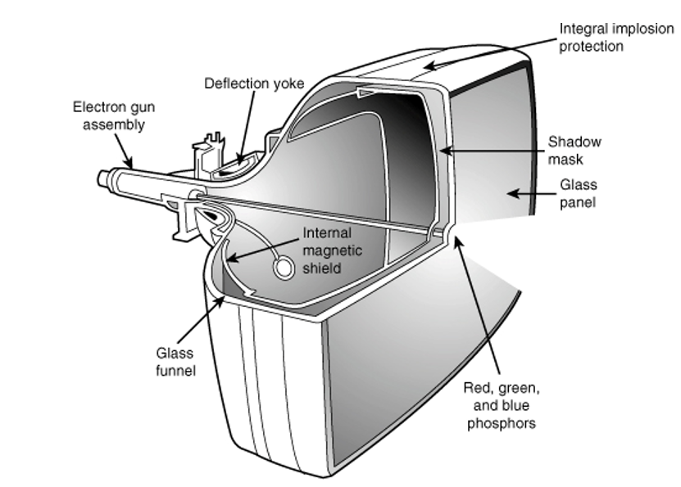

Figure 5. The Design of Typical CRT Color Monitor

Generally, the smaller the dot or stripe pitch, the clearer and sharper the onscreen image will be. Typical standards for CRT monitors call for a dot pitch of .28 millimeters (mm) or smaller. Generally, low-cost monitors have poorer picture quality than higher-cost monitors of the same size because of wider dot pitch, low refresh rates at their highest resolutions, and poor focus at their highest resolutions.

Typical CRT displays range in size from 15 inches (diagonal measure) to 19 inches, and feature support for a wide range of resolutions. CRTs are analog display devices that can display an unlimited range of colors, and use the 15-pin VGA connector. To learn more about VGA connectors, see the section "VGA," later in this chapter.

## Internal Structure of CRT Monitor

This device allows, the amplitude of signal, to be display primarily as a function of time, is called cathode ray oscilloscope. The cathode ray tube (CRT) is the heart of the C.R.O. the CRT generates the electron beam, accelerates the beam deflects the beam and also has a screen where beam become visible as a spot. The main parts of the CRT are

1. Electron gun
2. Deflection system
3. Fluorescent screen
4. Glass tube or envelope
5. Base

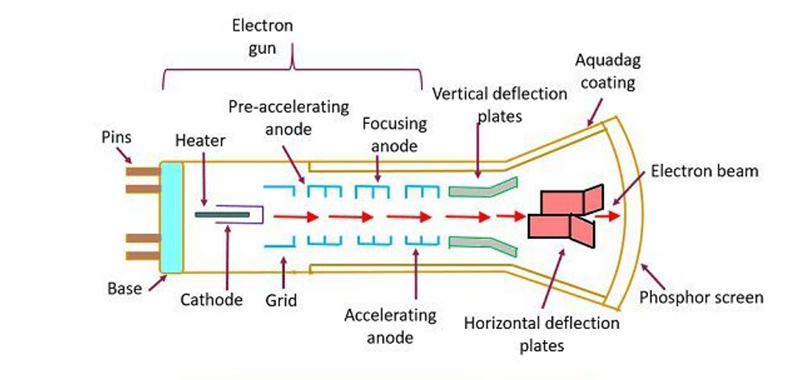

Figure 6. Internal Structure Mechanism of CRT Monitor

**Electron Gun**

* The electron gun section of the cathode-ray tube provides a sharply focused, electron beam directed towards the fluorescent-coated screen.
* This section has three main parts:
  + A heated metal cathode emits electrons, entering the electron gun.
  + The control grid is positioned in front and restricts the electron emission.
  + The accelerating anode accelerates the beam to high velocity.
* The gun consists of three electron emitters in a row, aiming to the screen.
* The light emitted from the fluorescent surface depends on electron beam intensity, or brightness, which is related to the quality of the electron beam.
* The electron gun is usually of three-gun construction.

**Deflection System**

* It is used to control the direction of the electron beam.
* It creates an electric or magnetic field which will bend the electron beam as it passes through the screen.
* In a conventional CRT, the yoke is linked to a sweep or scan generator.
* The deflection yoke which is connected to the sweep generator creates a fluctuating electric or magnetic potential.

**Fluorescent Screen**

* The light produced by the screen does not disappear immediately when bombarded by electrons (i.e., when the signal leaves the screen).
* The persistence of the screen means the area where the signal becomes zero is known as the "persistence of the screen."
* A phosphor is used to have a naturally fluorescent area, leaving an image of seconds or even minutes.
* Medium persistence screens are mostly used for general-purpose applications.
* Long persistence tubes are used only for traces of movement.
* Low persistence tubes fade quickly if transmitted since the next scan will soon cover the area after the screen has disappeared.

**Glass Tube**

* All the components of a CRT are enclosed in an evacuated glass tube called the envelope.
* This allows the emitted electrons to move about freely from one end of the tube to the other end.

**Base**

* The base is provided to the CRT through which the connections are made to the various parts.

## Color CRT Monitors

The CRT Monitor display by using a combination of phosphors. The phosphors are different colors. There are two major approaches for producing color displays with a CRT are:

* 1. **Beam Penetration Method**
  2. **Shadow-Mask Method**

**Beam Penetration Method**

The Beam-Penetration method has been used with random-scan monitors. In this method, the CRT screen is coated with two layers of phosphor, red and green, that produce display colors in these two ranges. A beam of low-energy electrons can excite only the red layer, while higher energy electrons penetrate through the red layer and stimulate the green phosphor layer. This method produces only four colors: red, green, orange, and yellow.Color variations are obtained in this case not simply by mixing the colors but by focusing the electron beam to excite either only a high-speed electron or multiple emitters in the same layer. This screen shows a green or red.

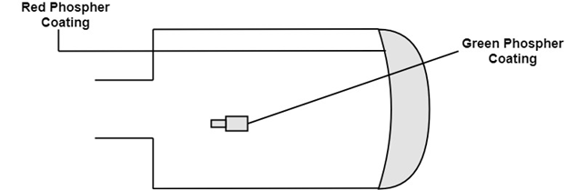

Figure 7. Beam Penetration Mechanism

**Shadow-Mask Method:**

Shadow Mask Method is commonly used in Raster-Scan System because they produce a much wider range of colors than the beam-penetration method. It is used in the majority of color TV sets and monitors.

**Construction:** A shadow mask CRT has 3 phosphor color dots at each pixel position.

* One phosphor dot emits:        - red light
* Another emits:                        -green light
* Third emits:                            - blue light

This type of CRT has 3 electron guns, one for each color dot and a shadow mask grid just behind the phosphor coated screen. Shadow mask grid is pierced with small round holes in a triangular pattern.

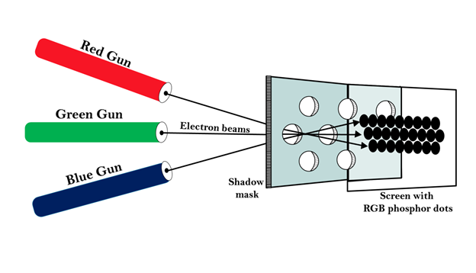

Figure 8. Shows the delta-delta shadow mask method commonly used in color CRT system.

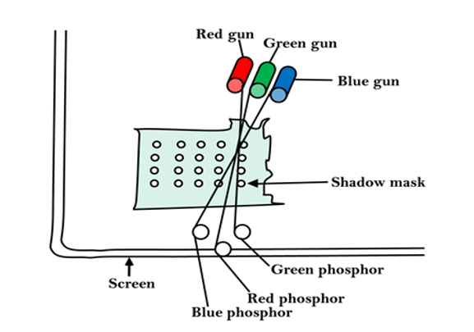

Figure 9. The shadow mask of CRT

**Triad arrangement**: of red, green, and blue guns.

The deflection system of the CRT operates on all 3 electron beams simultaneously; the 3 electron beams are deflected and focused as a group onto the shadow mask, which contains a sequence of holes aligned with the phosphor- dot patterns.

When the three beams pass through a hole in the shadow mask, they activate a dotted triangle, which occurs as a small color spot on the screen.

The phosphor dots in the triangles are organized so that each electron beam can activate only its corresponding color dot when it passes through the shadow mask.

**Inline arrangement:**

Another configuration for the 3 electron guns is an Inline arrangement in which the 3

electron guns and the corresponding red-green-blue color dots on the screen, are aligned along one scan line rather of in a triangular pattern.

This inline arrangement of electron guns in easier to keep in alignment and is commonly used in high-resolution color CRT's.

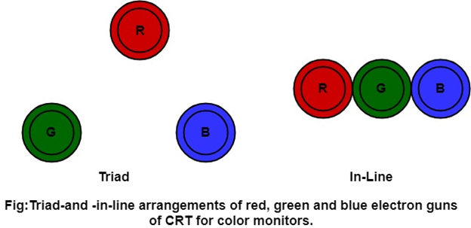

Figure 10. Triad and In-Line arrangement of red green and blue electron guns of CRT for Color Monitor

## Major Parts and Components of a Color Monitor

The **major parts and components of a color monitor** include various elements that work together to produce images on the screen using the RGB color model. Here’s an explanation of each part and its function:

* **Electron Gun**:
  + The electron gun is located at the back of the monitor's picture tube. It generates a stream of electrons and directs them toward the screen. In a color monitor, there are typically three electron guns, one for each primary color: red, green, and blue.
  + These guns emit beams that interact with the phosphors on the screen to create different colors by varying the intensity of each color's electron beam.
* **Deflection System**:
  + This system includes vertical and horizontal deflection coils around the tube. It controls the path of the electron beams, moving them across the screen from left to right and top to bottom.
  + By rapidly changing the direction of the beams, the deflection system ensures that the electron beams cover the entire screen, creating a complete image.
* **Shadow Mask**:
  + The shadow mask is a metal grid located just before the phosphor layer on the screen. It contains tiny holes that guide the electron beams, ensuring that each beam hits only the correct phosphor dots (red, green, or blue) for precise color representation.
  + The mask helps to prevent the beams from "bleeding" into adjacent color areas, maintaining the clarity and sharpness of images.
* **Phosphor Coating**:
  + The inside surface of the screen is coated with phosphor dots in red, green, and blue. When the electron beams hit these phosphors, they emit light, producing visible colors on the screen.
  + By varying the intensity of each electron beam, the monitor can display millions of color combinations.
* **Screen (Front Panel)**:
  + The front panel is the visible part of the monitor where images are displayed. It’s typically made of glass and is designed to protect the internal components.
  + The front panel may also have anti-glare and anti-static coatings to enhance viewing comfort.
* **Anode (High-Voltage Supply)**:
  + The anode provides a high-voltage electric field that accelerates the electron beams toward the screen.
  + This high voltage ensures that the electrons have enough energy to illuminate the phosphors brightly and consistently.

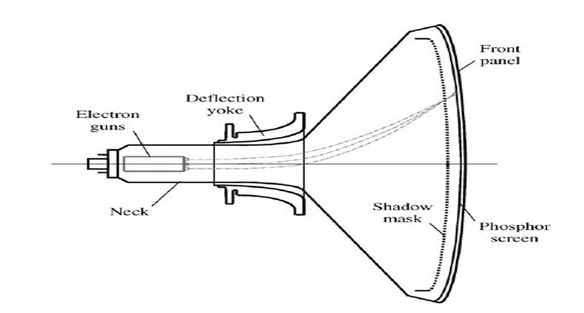

Figure 11. Components of CRT monitor

## Working Mechanism

The **electron gun** generates beams for red, green, and blue colors, which are directed by the **deflection system** to scan across the **phosphor-coated screen**. The **shadow mask** ensures each beam hits the correct color phosphor (red, green, or blue) by blocking electrons from hitting unintended colors. When the electrons hit the phosphors, they emit light, creating images on the screen in various colors based on the RGB model. The intensity of each electron beam can be adjusted to control the brightness of each color, allowing the monitor to display a wide range of colors and images

A color monitor is a display monitor that can display many colors. They use the RGB color model, which uses three different phosphors that appear red, green, and blue when activated. Color monitors can display text and graphics in multiple colors through the use of alternating-intensity red, green, and blue phosphors.

Color monitor can be divided into two groups. They are:

1. Composite color monitor
2. RGB color monitor

**Composite color monitor:**

A composite color monitor receives an analog video signal and may require interface logic in the form of an analog comparator video signal. A composite video interface can handle all information in an analog conductor

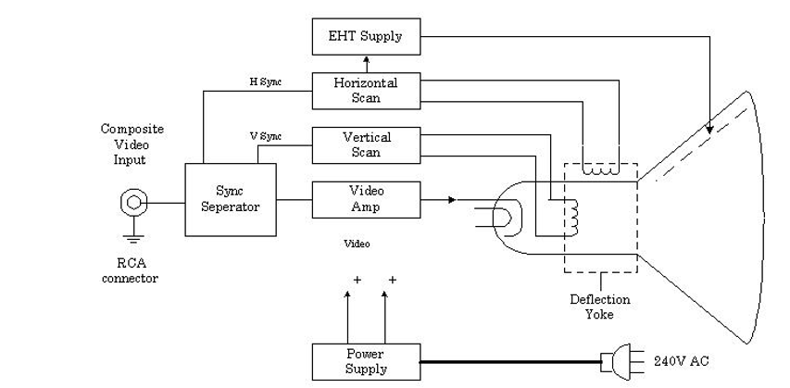 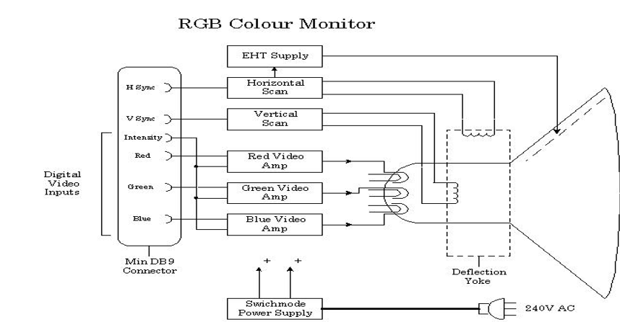

Figure . RGB Color Monitor and Composite Monochrome Color Monitor

**RGB color monitor**  
An RGB color monitor is a computer monitor with a lighting system that illuminates the back of the screen with red, green, and blue light. White light can be created from this mix, and the brightness of each color can be varied.

**Display panel**: Usually made of glass or plastic, the display panel contains pixels that are illuminated by the backlighting system.

**Backlighting system**: Illuminates the pixels on the display panel.

**Electronic circuits**: Inside the monitor are electronic circuits, which decode signals from the computer's graphics card, control the light crystals and signal each LED to turn on.

**Liquid crystal**: Each pixel is a tiny structure with a liquid crystal that changes its molecular structure when an electric charge is applied.

**Phosphor dots**: These comprise a triad of tiny color phosphor dots (typically red, green, blue) for each pixel on the screen.

**Thin film transistors**: These are thin films that form each red LED or each color LED module, and control each sub-color LED module.

**Pixel Grid**: The pixels are a series of horizontal and vertical arrays arranged in a grid. Each pixel consists of red, green, and blue sub-pixels, which are illuminated in different amounts to create colors.

**Color Filters**: Color filters are used to control the passage of light through each pixel. Red, Green, and blue color filters are used to adjust the wavelength of light to make it easier to create a full spectrum of colors.

**Signal Processing Circuitry**: The signal processing circuitry interprets signals from the computer's graphics card, converting them to pixel values.

**Graphic Card Connection for Video**: From the graphics card, external connectors transmit data to the monitor via the VGA connection to match the monitor's pixel matrix.

**Power Supply**: The monitor’s power supply provides the necessary power to the monitor, ensuring optimal illumination and operation of the display.

**External Part of Color Monitor:**

**Screen:** The screen is the visible display area where images and content are presented. It can be flat or curved, and its size is usually measured diagonally in inches.

**Bezel:** The bezel is the frame around the screen. It can be slim or wide, and its design may vary between models and manufacturers.

**Stand/Base:** The stand or base supports the monitor and allows users to adjust its height, tilt, and sometimes swivel for ergonomic positioning.

**Controls/Buttons:** Physical buttons or touch-sensitive controls are located on the front or side of the monitor. They allow users to navigate menus, adjust settings, and power the monitor on/off.

**Ports:** Input/output ports on the monitor allow connectivity with external devices. Common ports include HDMI, DisplayPort, USB, and audio jacks.

**Built-in Speakers:** Some monitors come with integrated speakers, providing audio output without the need for external speakers.

**VESA Mounting Holes:** VESA (Video Electronics Standards Association) mounting holes on the back of the monitor allow it to be attached to a compatible wall mount or monitor arm.

**Cables:** Monitors come with various cables for connecting to the computer, such as power cables, HDMI, DisplayPort, or USB cables.

**Power Button/Indicator:** The power button turns the monitor on/off, and an indicator light often shows the power status (on, standby, or off).

**On-Screen Display (OSD) Menu:** The OSD menu is accessed through the monitor's controls and allows users to adjust settings such as brightness, contrast, color balance, and more.

# Dot-Matrix Printer

## Overview

A dot matrix printer is an impact printer that uses a set number of pins or wires to print. It works by pressing an ink-covered ribbon against the paper to create tiny dots. The print head, which holds the pins, moves across the page to produce characters.

Dot matrix printers use a matrix of pins, which are used to produce the characters on the page. When it comes to variation in this regard, you can choose from either 9 pins or 24 pins – 9 pin is usually the fastest option, while 24 pins offer the highest resolution.

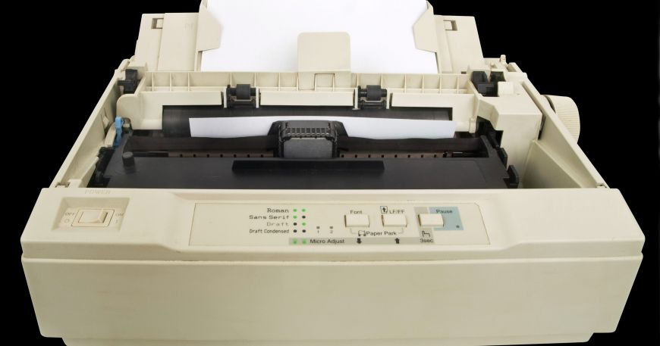

Figure . A Dot-Matrix Printer

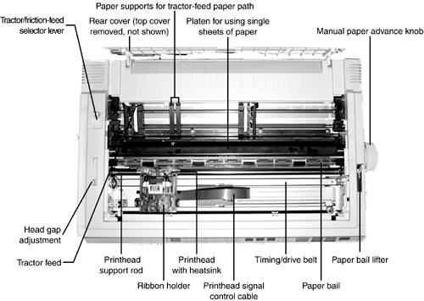

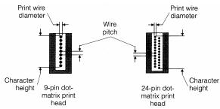

Figure . Disassembly parts of a Dot-Matrix printer

Mechanical and electronic parts of a Dot-Matrix Printer:

1. Printer Body
2. Cartridge
3. Power Supply Unit
4. Power Transformer
5. Motherboard
6. Stepper Motor
7. Print Head
8. Timing Belt
9. Sensor
10. Paper Feed Roller
11. Tractor
12. Control Panel

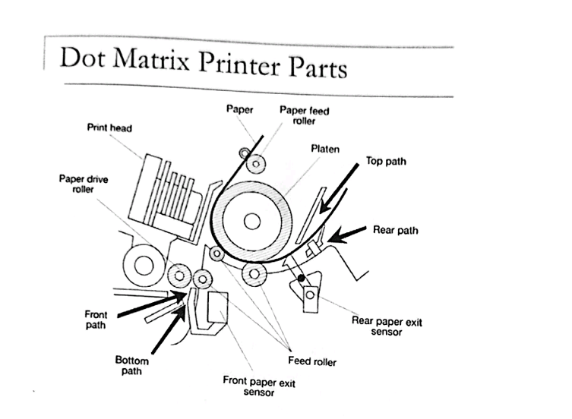

Figure . Parts in a dot-matrix printer

**Printer Body:**

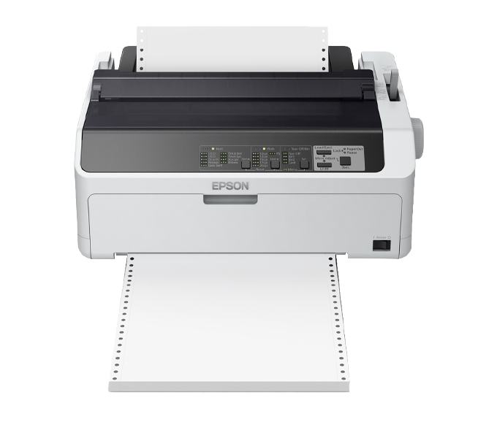

Figure . Printer Body

The body of a dot-matrix printer has a print head that contains a matrix of pins or wires. The pins are driven forward through an ink-soaked ribbon by electromagnets. The print head moves from left to right to generate text.

**Cartridge:**



Figure . Printer Cartridge

A dot-matrix printer cartridge is made up of cassette and a fabric ribbon that is inked. The ribbon is a long strip of material with holes in it. When the cartridge is installed, the holes line up with the print head, and ink flows through the holes onto the paper.

**Power Supply Unit:**

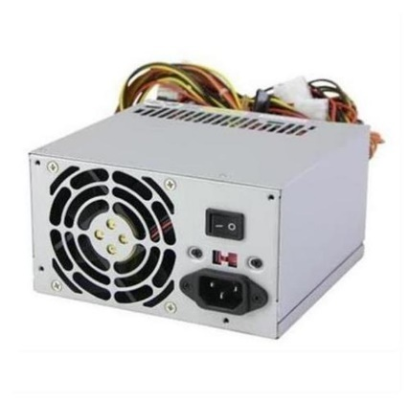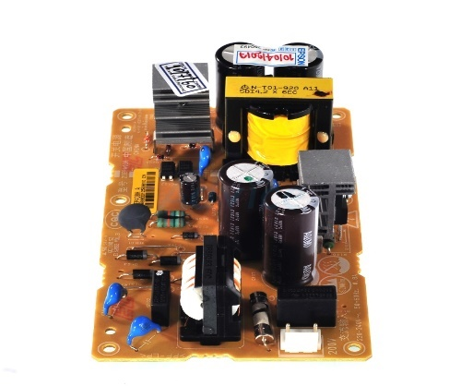

Figure . Power Supply Unit of a Dot-Matrix printer

The power supply unit of a dot-matrix printer contains two DC power outlets that supply DC 12v power to the printer.

**Power Transformer:** A 2-inch dot matrix printer RMP130 has power modules, which include an AC DC converter, optoelectronics, buzzers, MOSFETs, inductors, coils and transformers.

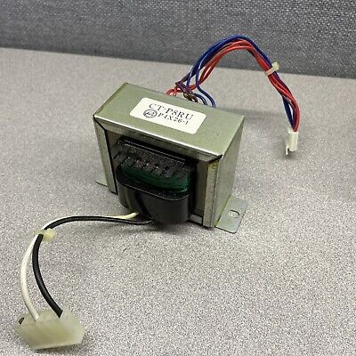

Figure . Power Transformer of a Dot-Matrix printer

**Motherboard:** A motherboard can be used as a main board for printers and as a baseboard for paper.

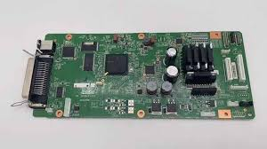

Figure . Motherboard of a dot-matrix printer

**Stepper Motor:** A stepper motor is a brushless DC motor that can rotate in small angles, known as steps. Stepper motors are often used in printers and robotics because they can move an object to a repeatable position.

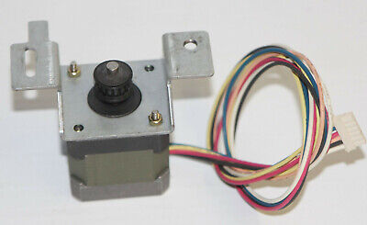

Figure . Stepper Motor of a dot matrix printer

**Print Head:**

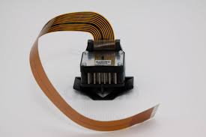

Figure . Print Head of a dot-matrix printer

A dot-matrix printer’ s print head is a matrix of pins that moves across the paper. The print head contains 9-24 fine wires, called pins, arranged in one, two, or three columns. The pins are thin metal wires with a tip less than a 50th of an inch across.

**Timing Belt:** Timing belts are essential components of many types of machinery, including printers. Epson timing belts are responsible for synchronizing the movement of the printer’s carriage and print head, ensuring that they move together and produce accurate prints.

**Sensor:** Dot-matrix printers have many different types of sensors, including:

* Paper out sensors
* Print head position sensors
* Ribbon end sensors

Each sensor has a unique function, such as detecting paper presence or monitoring the print ribbon’s lifespan.

**Paper Feed Roller:** A dot-matrix printer’s feed roller is a steel roller that supports the platen assembly. It moves in a direction to and from the printing means.

**Tractor:** A tractor feed is a common feature of dot matrix printers. It allows the printer to pull paper through. Dot matrix printers can use fanfold continuous paper with tractor holes.

**Control Panel:** A dot matrix printer’s control panel is located on the front of the printer. It is made up of three elements:

* Liquid Crystal Display (LCD) panel
* Indicator lights
* Buttons

# Inkjet Printers

In the digital age, inkjet printers have become ubiquitous in both homes and offices, providing affordable and high-quality prints for documents, images, and graphics. These versatile machines are prized for their compact design and ability to deliver detailed prints. But how exactly do they work? In this article, we’ll explore the fascinating technology behind inkjet printers and their components.

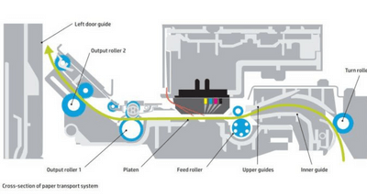

Figure 23: Inject Printer

Inkjet printers operate by spraying microscopic droplets of ink onto paper to create images and text. This precise process allows for vibrant colors and sharp details, making them ideal for various printing tasks, from photos to text documents.

## The primary components of an inkjet printer include:

* **Print Head:** The core of an inkjet printer, the print head contains tiny nozzles or jets that spray ink droplets onto the paper. Each nozzle can fire thousands of droplets per second, creating detailed images with high accuracy.
* **Ink Cartridges:** Inkjet printers typically use separate cartridges for each color (cyan, magenta, yellow, and black). These cartridges supply ink to the print head and can be replaced individually when empty.
* **Stepper Motor and Belt:** These parts work together to move the print head back and forth across the paper, ensuring the ink is deposited precisely where needed.
* **Paper Feed Mechanism:** The paper feed mechanism guides sheets from the tray into the printer. Roller’s grip and feed paper into the print area in sync with the print head’s movement.
* **Control Circuitry:** This circuitry coordinates the entire printing process, interpreting data from the computer and converting it into instructions for the print head and other components.

These components work together to produce high-quality, accurate prints. Inkjet printers can vary in design and features across brands, but most follow the same principles for basic operation.

## How Inkjet Printers Work?

The inkjet printing process is sophisticated yet elegant. Here’s a breakdown of how an image or text document makes its way from the screen to the printed page:

1. **Image Processing**: The document or image file is sent from the computer to the printer, where control circuitry processes the data and determines the ink droplet placement.
2. **Ink Droplet Formation**: Ink droplets are formed using either thermal or piezoelectric technology, depending on the type of inkjet printer. In thermal inkjet printers, heat is applied to the ink, creating a bubble that forces a droplet out of the nozzle. In piezoelectric printers, a crystal in the nozzle vibrates to push out droplets without heat.
3. **Precise Droplet Placement**: The stepper motor moves the print head across the page while tiny nozzles release ink droplets according to the processed data. This coordinated movement ensures that colors and shapes are accurately recreated.
4. **Layered Ink Application**: In color printing, multiple passes of the print head layer different colors on top of each other to produce rich, vibrant images. The paper feed mechanism advances the sheet incrementally as the image builds up.
5. **Final Output**: Once the image is complete, the printed sheet is ejected. Depending on the model, some printers might dry the ink using heat or air to prevent smudging.

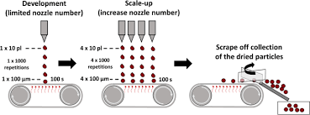

Figure 24: Inject Printer workflow

## Maintenance And Troubleshooting Tips OF An Inject Printer

**Maintenance**

* **Print Head Cleaning**: Use the printer’s built-in cleaning function regularly to keep nozzles unclogged. For stubborn clogs, a manual cleaning kit can be helpful.
* **Use Quality Ink**: Only use recommended ink cartridges for your printer model to avoid compatibility issues and ensure optimal performance.
* **Proper Storage**: Store the printer in a dry, dust-free area to avoid clogs and damage. Avoid placing it in direct sunlight or near heat sources.

**Troubleshooting**

* **Print Quality Issues**: If prints appear streaky or faded, check the ink levels and clean the print head. Running a nozzle check test can help diagnose issues.
* **Paper Jams**: Ensure the paper is loaded correctly and that the tray isn’t overfilled. Remove any stuck paper carefully to avoid damaging internal components.
* **Connectivity Issues**: If the printer isn’t connecting to your device, try restarting both the printer and the computer. Check the USB or network connections, and reinstall the printer driver if necessary.
* **Low Ink Warnings**: Replace cartridges as needed, and avoid printing when ink is extremely low to prevent air from entering the print head.

Inkjet printers are versatile and efficient, making them a great choice for both home and professional use. Understanding how they work and maintaining them well can help you make the most out of your printer for years to come.

# Laser Printers

In the modern world, laser printers have become an integral part of our daily lives, enabling us to produce high-quality text and images with remarkable speed and precision. These machines have revolutionized the way we produce documents, offering high-speed, high-quality printing. But have you ever wondered how laser printers work their magic? In this blog post, we’ll dive into the fascinating world of laser printers and explore the technology behind their functioning.

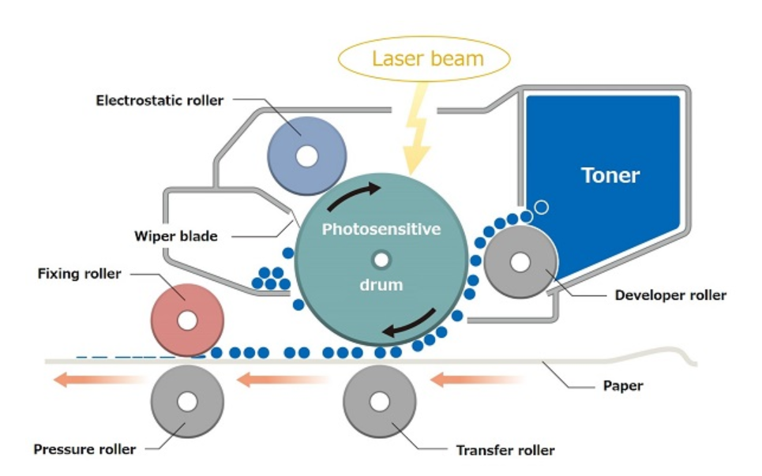

Figure 25: Laser Printer

Laser printers are widely used in offices and homes for high-quality printing. They work by using a laser beam to create an electrostatic image on a photosensitive drum, which is then transferred onto paper using toner. The paper is then fused with the toner using heat.

## The basic components of a laser printer include:

**Photosensitive Drum:** This is a critical component that receives the laser’s light. The drum is coated with a photosensitive material that becomes charged where the laser hits it. This charged area attracts toner particles to form the image.

**Laser Assembly:** The laser assembly emits a laser beam that’s directed onto the photosensitive drum. The laser beam selectively discharges the charged areas of the drum’s surface, creating a pattern corresponding to the content to be printed.

**Toner Cartridge:** Toner is a fine powder containing pigments that form the image on the drum. The toner cartridge holds the toner and releases it onto the drum in response to the drum’s electrostatic charge pattern.

**Developer Unit:** This unit includes a set of small, negatively charged beads that are mixed with the toner. The developer unit charges the toner particles, ensuring they are attracted to the oppositely charged areas on the drum’s surface.

**Transfer Corona Assembly:** After the drum is coated with toner, the image is transferred from the drum to the paper. The transfer corona assembly creates an electrostatic charge on the paper that attracts the toner particles from the drum.

**Fuser Assembly:** The fuser assembly consists of heated rollers. After the toner has been transferred to the paper, it passes through the fuser assembly, where heat and pressure fuse the toner particles onto the paper’s surface.

**Paper Feed System:** Laser printers have mechanisms to feed paper from a paper tray into the printing area. This system includes rollers that help move the paper through the various stages of printing.

These components work together to produce high-quality printed documents efficiently. Keep in mind that there might be variations in design and features across different laser printer models, but the fundamental components mentioned above are common to most laser printers.

## How do laser printers work?

Everyone understands the basic principles behind how an inkjet printer works – the printer sprays the page with minute amounts of ink, in the required combination to recreate the desired color. It does this until your image is recreated on paper. There’s more to it than that, of course, but that is the essence of what is going on.

Laser printers are more complex, however. The process involved in getting what’s on your computer screen to your printer is really quite ingenious!

The secret to how laser printers work is static electricity. A component called the drum is given a positive electrostatic charge via electrical current; a small laser then draws the needed images onto the drum, creating what is called an electrostatic image – sort of a negative image where the background is negatively charged and the foreground – the images you want printed – are positively charged.

Toner is then sprayed onto the drum – with a positive charge, the toner clings to the negatively charged areas of the drum. The image is then ready to be transferred to a sheet of paper. The sheet of paper itself is then given a negative charge – stronger than the one on the drum – so that the toner is pulled away from the drum. As the sheet of paper rolls along the drum it is discharged – otherwise it would cling to the drum itself!

Next for the paper is a trip through the fuser – basically two hot rollers – which melts the toner onto the page, fixing the image. Paper is always warm coming out of a laser printer, and that is why. After each sheet the drum is discharged by a bright light called the discharge lamp, and the entire surface again given a positive charge, ready for the next image.

And that’s about it! It’s a simplified version of the full process, of course, but nonetheless shows how complex the steps are to get your image printed onto paper. When servicing your own laser printer, you’ll note that some feature separate drum units and toner cartridges, while others have a combined drum/toner cartridge assembly. If you’re not sure which type of cartridge your printer takes, contact us and we’d be glad to let you know!

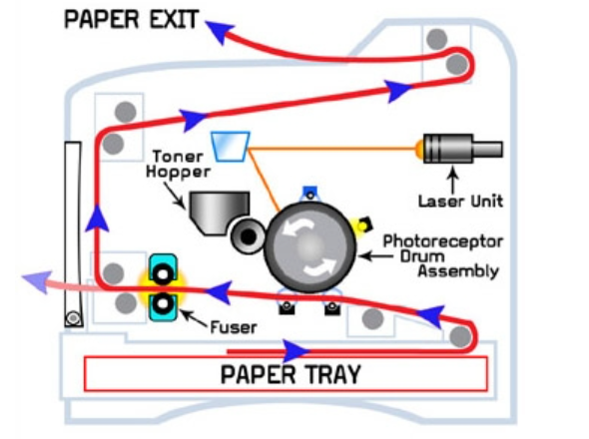

Figure 26: Laser Printer workflow

## Factors Affecting Print Quality and Speed

The print quality and speed of a laser printer can be influenced by various factors, including hardware specifications, software settings, and the type of document being printed. Here are some key factors affecting print quality and speed in laser printers:

**Resolution:** The resolution of a laser printer is measured in dots per inch (dpi). The higher the resolution, the sharper and more detailed the print will be. Most laser printers have a resolution of 600 dpi, but some high-end models can print at resolutions of up to 1200 dpi or more.

**Color depth:** The color depth of a laser printer is measured in bits per pixel (bpp). The higher the color depth, the more colors the printer can produce. Most laser printers have a color depth of 24 bpp, which is capable of producing over 16 million colors.

**Paper quality:** The type of paper you use can also affect the print quality. Laser printers are designed to work best with high-quality paper that is made specifically for laser printers. Using poor-quality paper can result in faded or blurry prints.

**Print speed:** The print speed of a laser printer is measured in pages per minute (ppm). The faster the print speed, the less time it will take to print a document. The print speed of a laser printer can be affected by the resolution, color depth, and paper type.

**Print settings:** The print settings you choose can also affect the print quality and speed. For example, choosing a higher resolution will result in a sharper print, but it will also take longer to print.

**Printer maintenance:** Regularly cleaning and maintaining your laser printer can help to improve its print quality and speed. This includes tasks such as cleaning the printhead, rollers, and fuser.

In general, higher resolution, color depth, and print speed will result in better print quality, but they will also take longer to print. The best way to choose the right settings for your needs is to experiment and see what works best for you.

**Maintenance And Troubleshooting Tips**

Maintaining and troubleshooting laser printers is essential to ensure they work efficiently and have a longer lifespan. Here are some maintenance and troubleshooting tips for laser printers:

**Maintenance**

* Clean the printhead regularly. This can be done using a cleaning kit that is specifically designed for your printer.
* Defragment the printer’s hard drive. This can help to improve the printer’s performance.
* Keep the printer in a cool, dry place. This will help to prevent the printer from overheating and malfunctioning.
* Avoid printing on wet or damp paper. This can cause the paper to jam and damage the printer.

**Troubleshooting**

* If the printer is not printing, check to make sure that it is turned on and that the power cord is plugged in.
* If the printer is still not printing, try printing a self-test page. This will help to determine if the problem is with the printer or with the computer.
* If the self-test page prints, try clearing the printer’s paper jam.
* If the printer is still not printing, check the ink or toner levels. If the levels are low, replace the cartridge.
* If the printer is still not printing, contact the printer manufacturer for assistance.

By following these tips, you can help to keep your laser printer in good working condition and avoid costly repairs.

# Mouse

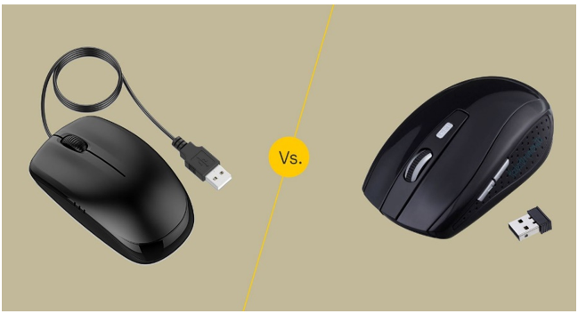

Figure . A Typical wired (left side) and wireless (right side) computer mouse

A mouse is an input device that is moved across the desk surface by the user so as to interact with the computer. It basically interacts with the Graphical User Interface of the computer. A mouse is used to perform actions such as selection, double-clicking, dragging, scrolling etc. Many kinds of mouse have been introduced and each of them its own purpose. In cases of laptop, the mouse is an external touchpad that has been embedded in front of the keyboard. However, users can use an external mouse for interaction with the computer.

This report details the examination of a computer mouse, focusing on its external design internal components.

## External Parts of a mouse

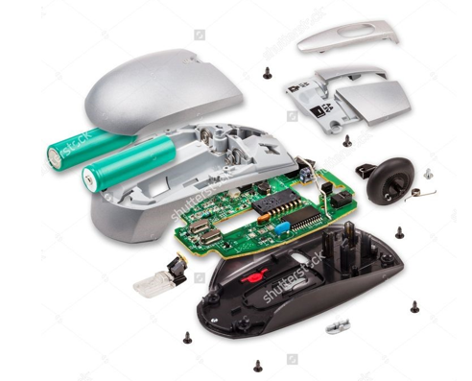

Figure 28. External Parts of a Computer Mouse

The external components of a computer mouse generally include:

1. **Left and Right Buttons**: Main clickable areas on the mouse, often used for selecting and interacting with on-screen elements.
2. **Scroll Wheel**: Allows for vertical scrolling through pages or documents; in some mice, it also clicks as a middle button.
3. **DPI (Dots Per Inch) Button** (on some mice): Adjusts the sensitivity or speed of the mouse pointer.
4. **Side Buttons** (optional): Extra buttons, usually for quick navigation, often customizable for functions like forward/backward navigation in browsers.
5. **Sensor Area**: Located on the underside of the mouse, this is where the optical or laser sensor is positioned to detect movement.
6. **Cable/Connector** (for wired mice): Connects the mouse to the computer’s USB port.
7. **Battery Compartment** (for wireless mice): Holds the batteries powering the mouse.
8. **Power Switch** (for wireless mice): Allows the user to turn the mouse on or off to conserve battery life.

Each component contributes to the mouse’s functionality and ease of use for tasks and applications.

## Internal Parts Observation

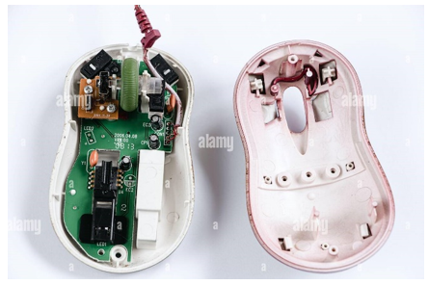

Figure . Internal Parts Observation of a mouse

The internal components of a computer mouse typically include:

1. **Circuit Board**: The main internal board where all electronic components are mounted. It processes signals from the buttons and sensor and communicates with the computer.
2. **Optical or Laser Sensor**: Detects movement by capturing images of the surface beneath the mouse and translating them into cursor movement.
3. **Microcontroller/Processor**: Acts as the “brain” of the mouse, processing input from the buttons and sensor to send signals to the computer.

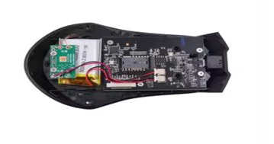

Figure . Microcontroller of a mouse

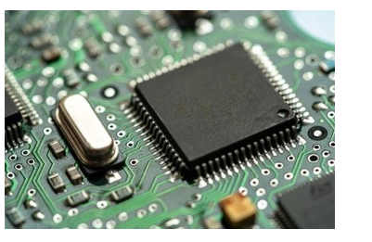

Figure . Circuit board of a mouse

1. **Switches**: Located beneath the left and right buttons (and sometimes additional buttons), these registers click by making or breaking electrical connections.
2. **Scroll Wheel Mechanism**: Contains an encoder that detects wheel rotation, allowing for scrolling in documents or web pages.
3. **Battery and Power Management Circuit** (for wireless mice): Supplies power to the mouse and manages power distribution across components. Some may include rechargeable batteries and charging circuits.
4. **Wireless Transmitter/Receiver** (for wireless mice): Communicates input data to the computer using Bluetooth or radio frequency (RF) signals.
5. **LED Light (in optical mice)**: Emits light that reflects off the surface to aid in tracking movement; typically red or blue LEDs are used.
6. **DPI Adjustment Mechanism** (for high-precision mice): Allows users to adjust the sensitivity of the sensor, often through a dedicated DPI button connected to the circuit board.
7. **Resonator/Crystal Oscillator**: Provides a clock signal that helps synchronize data processing within the microcontroller.

Each of these internal components works together to translate physical movement and clicks into digital signals for the computer.

# Scanner

A Scanner is an electronic device that is used to read and convert documents such as photographs, magazines, posters, and images into digital copies for display, editing, and archiving. The digital copies can be further modified by using different software tools. Most scanners are connected to computers using cords that plug into a port that is readily accessible. Some modern scanners also come equipped with Bluetooth and wireless features which offer greater accessibility and flexibility. Scanners work in conjunction with software applications. By installing scanning plug-ins, the images can be directly imported into the software applications. For example, by installing a plug-in for Adobe Photoshop the users can create new images directly from the linked scanner.

**How Does a Scanner Work?**

Different versions from different companies may have slight variations in the working and design but the core principle remains the same among all the scanners.

The document is placed on the scanner and the lid is closed after which a light source is used to illuminate the document from below. A scan head which comprises of mirror, lens, filter and CCD (Charge-coupled device) array is then moved across the document with the help of a belt and a stepper motor. A stabilizer is used to keep the scan head stable. A pass means that the scan head has completed one complete scan of the entire document. The image of the document is then reflected by an angled mirror on another secondary mirror. Secondary mirror reflects the image onto a lens. The lens focuses the image on the CCD array through a filter. The arrangement of the lens and CCD array may differ from scanner to scanner. Most scanners utilize a three pass method where different color filters (red, green or blue) are used between the lens and CCD array to generate the image. After all the three passes are complete the software assembles all the three filtered images into a single full-color image.

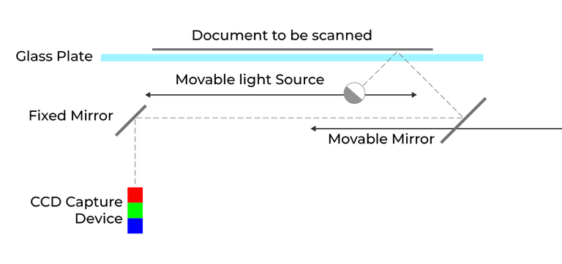

Figure . Scanning method

**Types of Scanner:** There are several types of scanner that are mentioned below.

## Drum Scanner

The drum scanner rotates scanned page around a drum for faster scanning. It scans with a photomultiplier tube rather than a charge-coupled device which is used in flatbed scanners. The drum scanners use photomultiplier tubes which are excessively sensitive to light. The image is mounted on the glass tube available in the scanner and when the scanning start the light is moved on top of the image while the photomultiplier tubes (PMT) pick up its reflection and process it. Drum scanners are generally known for their high resolution.

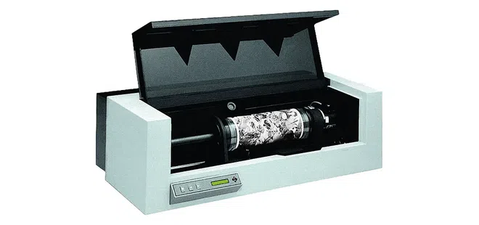

Figure .drum scanner

## Flatbed Scanner

It is the most commonly used type of optical scanner which is readily available in the market. The documents are placed on a flat surface by lifting the cover and then the lid is closed after placing the documents. It is easy to operate and user friendly. It can be used to scan a wide variety of documents such as books, magazines and images. Some flatbed scanners also come equipped with Bluetooth or wireless technologies as well as automatic feeders which makes the process easy and simple.

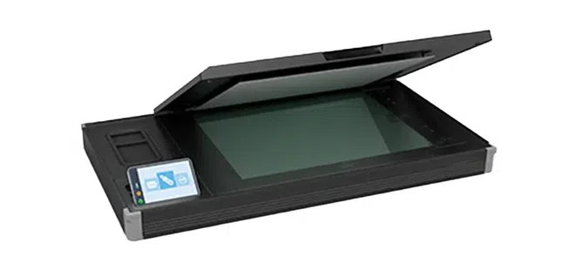

Figure . Flatbed Scanner

## Sheetfed Scanner

The main characteristic of a sheetfed scanner is that they are specifically designed to handle loose sheets of paper. These scanners are great in scanning enormous amount of paper sheets. They are generally a little smaller than flatbed scanners and feature a lesser image resolution. They are mainly used by business and offices who have a limited amount of space. Sheetfed scanners are fast in terms of paperweight and size (pages per minute). They are equipped with a feeder tray which automatically feeds into the scanner.

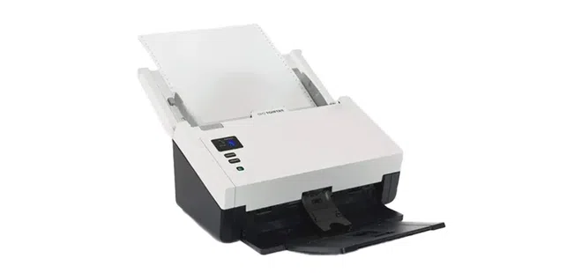

Figure . Sheetfed Scanner

## Handheld Scanner

It is a portable handheld device that works similarly to a flatbed scanner. Instead of inserting the document as its is done in flatbed, here, the scanner is dragged over the document to be scanned. Handheld scanners are preferred over flatbed scanner as they are very compact, easy to use and offer greater flexibility. They are mainly used in shopping stores and storage houses to evaluate goods by scanning barcodes.



Figure . Handheld scanner

**Uses of Scanner:** Copying, Archiving, Sharing Photos, Research, Portability

**Advantages of Scanner**

* Cost Effective

1. Reliability
2. Ease of Use
3. High Quality
4. Efficiency
5. Environment friendly

**Disadvantages of Scanner**

* Maintenance

1. Limited Functionality
2. Security Concerns
3. Quality Control
4. Physical Incompatibility

# HDD

An **HDD (Hard Disk Drive)** is a storage device that uses spinning disks and read/write heads to store and retrieve data. Here’s an in-depth look at its **internal components**:

**1. Platters**: The platters are circular, disk-like structures that store data magnetically. Typically made from aluminum, glass, or ceramic coated with a magnetic material. Data is written to or read from the platters using magnetic fields.

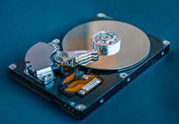

Figure 37. HDD platter

**2. Spindle**: The spindle is a motorized axle that holds and spins the platters. Spins the platters at high speeds (typically 5,400 to 15,000 RPM).

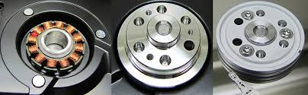

Figure 38.HDD spindle

**3. Read/Write Heads**: Small electromagnetic devices positioned just above the platters. The **write head** writes data to the platters by changing the magnetic orientation and the **read head** detects the magnetic fields on the platter surface to read data.

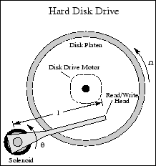

Figure 39. HDD Read/Write Heads

**4. Actuator Arm (or Actuator)** A mechanical arm that holds the read/write heads. Moves the heads across the surface of the platters to access different tracks. It uses an actuator (often an electromagnetic voice coil) to position the heads accurately.

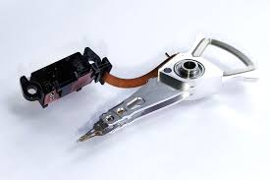

Figure 40. HDD Actuator Arm (or Actuator)

**5. Head Stack Assembly (HSA):** The combination of the actuator arm and the read/write heads. Coordinates the movement of the heads and ensures precise data access.

**6. Disk Controller (PCB)**: A printed circuit board (PCB) located on the bottom of the drive. Controls the operation of the drive, including: Managing data transfer, Translating data, Handling error correction, buffering, and power management

**7. Motor (Spindle Motor):** A motor that powers the spindle to rotate the platters. Ensures the platters spin at a consistent speed for data access.

**8. Cache (Buffer)**: A small amount of high-speed memory (usually DRAM) on the drive's PCB. Temporarily stores frequently accessed data for faster retrieval and improved performance.

**9. Interface Connector**: A physical connection that links the HDD to the computer (e.g., SATA, IDE, or SCSI). Enables data transfer between the drive and the computer's motherboard.

**10. Motorized Actuator (Voice Coil)** An electromagnetic coil used to precisely move the actuator arm. It adjusts the position of the read/write heads by moving the actuator arm across the platter surfaces.

**11. Suspension System:** A flexible mechanism that supports the read/write heads. Ensures that the heads float just above the platter surface, minimizing contact and wear.

**12. Platter Surface Coating:** The outer layer of the platter is coated with a magnetic material (usually a thin layer of iron oxide or cobalt alloy). Allows the platters to store data by changing the magnetic alignment when data is written.

# CD drive

A **CD drive** (Compact Disc drive) is an optical storage device that reads and writes data on CDs (Compact Discs). It uses laser technology to access the data stored on the surface of the disc. Here's a detailed description of its components and operation:

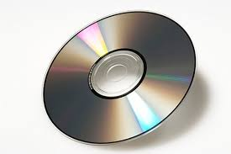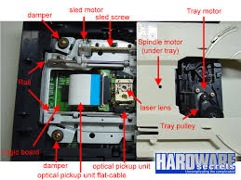

Figure 41. CD drive

**1. Laser Assembly:** The laser assembly includes a laser diode and lenses that focus the laser beam onto the surface of the CD. The laser is used to read the data encoded on the CD in the form of tiny pits and lands (indentations and flat areas) on the disc surface. The laser also helps in writing data to writable CDs (CD-R or CD-RW).

**2. Optical Pickup (or Head):** This component consists of the laser diode and the photodiode sensor, which is positioned over the CD surface. It emits a laser beam onto the disc and detects the reflected light. The changes in the light reflection (from pits and lands) are interpreted as binary data.

**3. Spindle Motor:** A small motor that spins the CD at a constant speed. It rotates the CD so that the laser can scan across the surface of the disc. The speed of rotation changes depending on the part of the CD being read (faster towards the inner part, slower towards the outer edge).

**4. Stepper Motor and Actuator**: A stepper motor drives the actuator mechanism that moves the optical pickup assembly. The actuator moves the laser head along the radius of the CD to read or write data across the entire disc surface. It positions the laser assembly with high precision.

**5. Optical Lens**: A lens focuses the laser beam onto the surface of the CD. It ensures the laser beam is tightly focused on the pits and lands to accurately read the data or to write on a writable disc.

**6. CD Disc:** A Compact Disc, typically 120mm in diameter and 1.2mm thick. The data is encoded in the form of tiny pits (indented areas) and lands (flat areas) on the disc surface.

**7. Data Encoding**: Data on the CD is encoded as a series of pits and lands arranged in a spiral track. The CD stores data using a technique known as **modulation**. The laser reads these patterns to interpret the stored data as digital bits (0s and 1s).

**8. Buffer Memory (or Cache)**: Some CD drives include a small amount of memory. Temporarily stores data as it is read from or written to the CD, helping to smooth data transfer between the drive and the computer.

**9. Controller Circuit:** This is the integrated circuit responsible for managing the data flow between the CD drive and the computer system. It translates the data from the CD into a format that the computer can understand and process, and vice versa when writing data to a CD.

**10. Interface Connector:** CD drives use interfaces like **IDE (PATA)**, **SATA**, or **USB** to connect to the computer. Facilitates data transfer between the CD drive and the computer system.

**How it Works:**

The CD is placed in the drive, where a motor spins it, and a laser shines onto the disc, reflecting light back to a sensor. Differences in the reflected light, caused by pits and lands on the disc, are interpreted as data. This data is either sent to the computer for use or, in the case of writable CDs, written by modifying the disc's surface with the laser.

**Uses of CD Drives:**

* **Reading CDs**: Music, software, and data stored on CDs.
* **Writing Data**: Creating CDs with custom data (like music, backups, or software).
* **Media Playback**: Playing music CDs or video CDs/DVDs (if the drive supports it).